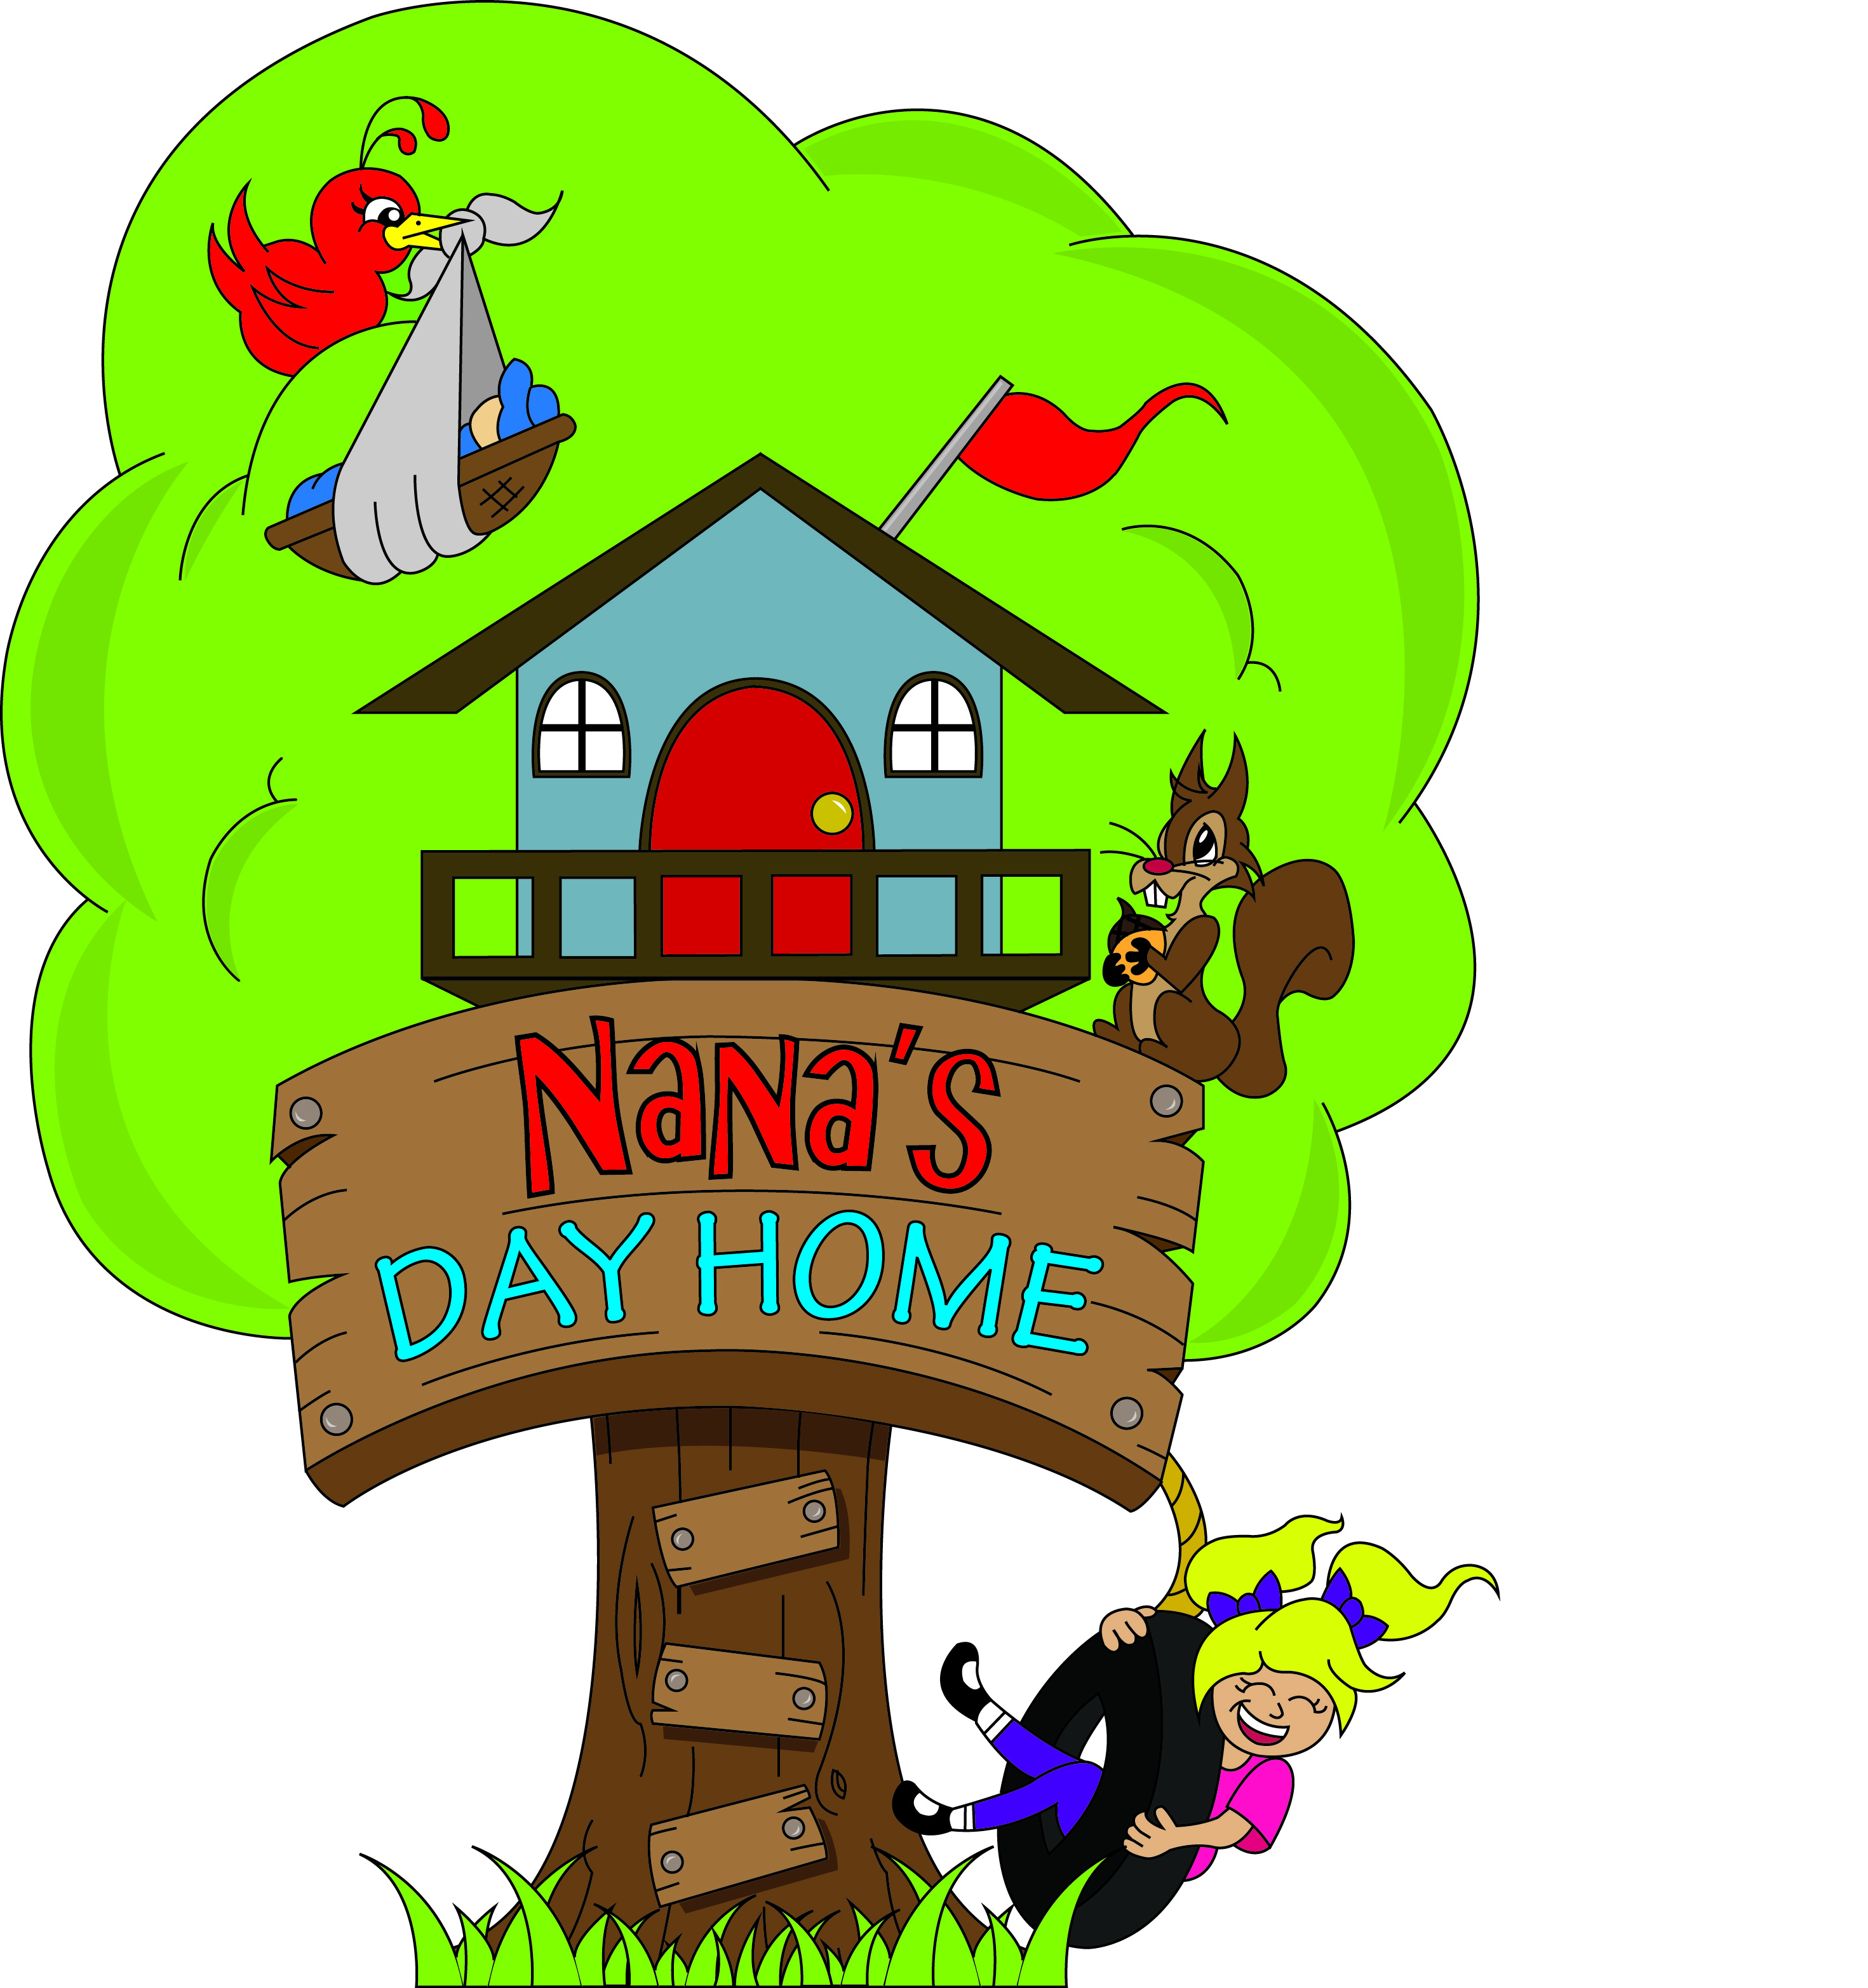
Parent Handbook
November 2012

Parent Handbook
Table of Contents

Page 1 Welcome

Page 2 Contact information
Hours
Licensing

Page 3 Fees

Page 4 Health Policy

Page 5 Behavior Guidance Policy
Parent Communication/Information

Page 6 Inclusion Philosophy
Inclusion Policy
Arrival & Departure

Page 7 Program
Daily Routine
Rest/Quiet Time

Page 8 Little Extra’s
Nutrition Policy

Page 9 Breast Feeding Policy
Weather Safety
Daily Requirements

Welcome to Nana's Day Home, an approved childcare facility where love, laughter and learning happen naturally. Approved Family Home Child Care has the same programming, nutritional, healthy & safety regulations as a licensed daycare but with the added advantage of a smaller group of children with the same caregiver everyday in a home environment.
Hi I am Lea Anne Joudrie an Early Childhood Educator with thirty years of experience in the field. I have a Diploma in Early Childhood Education with Honours with Distinction from the Institute for Human Services an Education .I also have additional training for children with special needs. I been through the Child Abuse Registry and have a clean criminal records check. I regularly attend early childhood education workshops, and hold certificates in Standard First Aid, Food Handling, Non Crisis Intervention and Tumble Bugs Trainer to name a few.
I provide a high quality inclusion program with nutritious meals and snacks for 6 children ages 1-5 years. My aim is to provide a warm, loving, safe, healthy unhurried environment where children and families are welcomed as individuals whose differences are accepted and respected. The program that I will be presenting to the children is planned to facilitate, stimulate and maximize intellectual, physical, social and emotional development.
When making inquiries for your child’s admission into childcare, you will have many questions and I have endeavoured to cover the most common areas in this handbook. For any questions not covered or need clarifications don’t hesitate to ask.
Sincerely,
Lea Anne

Page 1

Contact information:
Phone: (902) 895-4886

E-mail: nanasdayhome@bellaliant.net

Web: www.nanas.ca

Hours of Operation
Monday – Friday 7:30 a.m. to 5:30 p.m. excluding listed holidays
(additional hours may be approved upon request)

Licensing

Nana’s is approved family home child care supervised by IHSE Family Home Child Care Agency. The Agency is located at 60 Lorne St. Truro NS and the contact person is Cheryl Taylor {902 893-3342}.Family home day care agencies are licensed by the Department of Community Services to approve, manage and monitor the care providers in their homes.

Page 2

Fees
Fees are payable weekly, and include all meals and supplies, with the exception of diapers and formula/baby food for infants, and diapers for toddlers.
There is a deposit equal to one week's fees due upon registration. This fee will secure your child's spot in my dayhome. It will be applied to your child's last week of care providing proper notice of termination is given and no other outstanding monies are owed to me.
Child care service will not be provided to any family with fees in arrears. There will be a $20.00 charge for all NSF cheques. After one NSF cheque, all future payments must be made in cash.
Receipts will be issued for income tax purposes.

Nova Scotia’s Child Care Subsidy helps eligible families pay for childcare in approved family home day care therefore Nana’s is qualified to accept children who have portable subsidy seats. More Information on the subsidy program can be obtained by calling the Subsidy Caseworker at 893-6167.
Full Time Rate: Includes children who are registered to attend home care Monday-Friday during regular hours.
- One child -----------$150.00/week
- Two children in the same family -------$270/week

Part Time Rate: Includes children who are registered to attend home care between 2-4 days a week.
- One child-------------4 dollars per hour with a minimum fee of 20 dollars per day
- Two children in the same family-----7 dollars per hour with a min fee of 35 per day
Holidays on which I am closed are to be paid for if your child is registered for that day. Nana’s is closed for the following 10 holidays:
1. New Years Day 6. Labor Day
2. Good Friday 7. Thanksgiving Day
3. Victoria Day 8. Remembrance Day
4. Canada Day 9. Christmas Day
5. Civic Holiday (August) 10. Boxing Day
Absent days which your child is registered are to be paid as any other. Two weeks’ notice is to be given before withdrawal of your child.
Vacation time: I will advise you early of my vacation dates. Please let me know your vacation dates as soon as you know them, especially if they differ from mine. I take two to three weeks of unpaid vacation time each year
Page 3

Health Policy
If your child has a slight cough and stuffy nose they will be allowed to come to my dayhome. Based on the guidelines provided by the Department of Community Services and the Department of Health, children who have any of the following symptoms should remain at home.
Fever (101F/38.3C) persistent crying,
Vomiting more than once difficulty breathing,
Diarrhea more than once red itchy eyes
lethargy unidentified rash

Children with communicable diseases such as measles, flu or strep throat cannot return without Doctor approval. I reserve the right to request a Doctor’s note stating that the child is well enough to come to my home.

If a child becomes ill in a non-emergency way at Nana’s, I will contact the parents/guardian to pick the child up. In an emergency situation where immediate medical care is required I will call 911 first and contact parents/guardian second. If parents cannot be reached emergency contacts will be called.

Prescription medication and non prescription medication can be administered at Nana’s. Please ensure that the medication that you child requires remains in the container it came in. Parents will be asked to write a note authorizing medication prior to their child receiving it. Children’s backpacks should not contain creams or medications of any type.

As part of the Application Process parents are required to provide current immunization information for their child and indicate any health concerns. If parents have chosen not to have their child immunized they should indicate so on
the application form.

Page 4

Behaviour Guidance Policy
A well planned program which meets the needs of each child will generally eliminate inappropriate behaviour
- Have a positive attitude towards all children.
- The children will know what they CAN do rather than what they CANNOT do.

- Each child will be respected as an individual.

- Always respond in a consistent and appropriate manner.

- Re-Direction is the main form of behaviour guidance

- Food will not be used to reinforce positive behaviours, as a reward for completing a task, or consequence for inappropriate behaviours.

If you have any questions or concerns regarding this policy, please discuss them with me. There is also 6 page more detailed plan posted on bulletin board you are welcome to have a copy of.

Parent Communication/Information
Parents are encouraged to take a moment each day to talk to me about their child’s day. This helps promote a positive link between home and child care. Please take note of the parent board in entryway. The parent board is meant to give you more information on what’s going on in your child’s day so you can take on a more active role in your child’s day to day activities. Daily logs are kept for all children under three. The log tracks food /liquid input, bowel movements, naps, new achievements and how their day was. The family home agency has a parent committee that meets twice a year to share information. Information about past and upcoming meetings is posted on the main bulletin board. The meetings are open to any parent who would like to attend. If a parent has a concern about his or her child please make arrangements to meet with me to discuss the issue in private. I have an open door policy and parents are welcome to visit at any time.

The following items are posted on the main bulletin board for your viewing and to meet regulations.

(i) a copy of the Act and these regulations
(ii) a copy of the parent handbook,
(iii) the license for the facility,
(iv) a copy of the report of the most recent inspection of the facility,
(v) a copy of the licensee’s behaviour guidance policy,
(vi) a copy of the current menu,
(vii) a copy of the daily program plan and routine,
(viii) a list of the names of the current members of the parent committee
(ix) a copy of the most recent minutes of the parent committee,
(x) any information required by the Minister.

Page 5

Inclusion Philosophy
I believe I have a responsibility to provide a high quality inclusion program so every child regardless of their ability can achieve their full potential. By helping all children achieve their full potential in an inclusive environment, we can be instrumental in creating welcome and accepting attitudes. By celebrating human diversity we hope to contribute to a better long term social out come for everyone.

Inclusion Policy
- No child will be excluded from any activity
- I am open to work with other professionals like early intervention, speech therapists etc.
- I offer a developmentally appropriate program within the child’s chronological age group.
- All families have the same programs available to them.
- Parents are welcome to participate in any activity within their comfort level.
- I promote and support inclusion at home and in our community.

Quality Childcare is for all Children

Arrival and Departure

Arrival and departure times are carefully logged to ensure accurate records are kept in case of emergency. In order for me to be able to contact parents it is important to notify me you are going to be unavailable at your usual phone number.

Please call before 9:00 if your child will not be attending home care .

Children will not be released into the care of someone under the age of 16 or who is not designated for pick up on the child’s application form. Please make sure anyone picking your child up has the proper car seat for your child. For safety reasons children will not be released into the care of anyone appearing to be under the influence of drugs or alcohol

Page 6

Program
The well-being of your child is a partnership arrangement. As in any partnership, good co-operation and mutual respect are essential.
My program is designed to meet the needs of the whole child—emotionally, socially, physically and intellectually. I feel that children learn best by actively interacting with real materials, people and their environment. I provide for and encourage exploration and discovery in a worry-free, caring and fun atmosphere. A rich variety of materials and activities that challenge various skill levels are available.
The children and I (when they can talk) plan the curriculum based on the interests of the children. Observation and documentation make children's learning visible. My role as a teacher is supportive rather than authoritarian. I interact with the children as needed to extend, stimulate and support their efforts. This way of working sometimes leads to the development of long-term, in-depth projects. As a teacher I am a co-learners and researchers along with the children. An emergent curriculum allows children to explore and investigate personally meaningful tasks, to build and make things together, and to report their activities to each other and you their parents. The curriculum helps to foster; independence, confidence, feelings of self-worth, and positive social skills. I have found this programming directs us to many wonderful teachable moments. I have worked in collaboration with early elementary teachers and have been assured this type of programming has your child school ready and a joy to work with.

“Daily routine” means a written schedule of events that happen in a predictable order each day. These include arrival and departure, snacks and meals, nap/quiet periods, free play and small and large group gatherings (e.g., story time). The daily routine is posted on the bulletin board and these routines will vary based on the ages of the children and the group’s needs. The daily routine is flexible and is adapted to meet the needs of the children in the group. For example, story time is shortened when children are not engaged or interested; free play is extended when children are in the middle of a project and early risers are provided with quiet activities during the rest period.

Rest/Quiet Time Policy
Children have a rest period each day after lunch for 1 to 2 hours depending on their needs. This is a time to relax and refresh. Children are not forced to sleep nor are they forced to stay awake. A child who remains awake after a ½ hour quiet rest will be provided with quiet activities.
Please bring a blanket for your child that can be kept at the dayhome. I provide cribs, mats and sheets. All bedding is laundered at least once a week or as required. Some children like to bring a small soft toy to snuggle with at nap time. It should fit into their cubby and be washable as it will be washed weekly with their bedding.

Page 7

Little Extras

We will have the Tumble Bugs Program. This is a fun and safe modified gymnastics and basic movement program for preschoolers. The toddlers will be doing a tailored version. The program is done here and I am a qualified trainer. The program was developed by Gymnastics NS, Dept of Education and the NS Dept. of Heath Promotion and Protection. Children yoga will also be available

I feel music is an important part of every ones lives. Every day at Nana’s you will hear & see lots of music, singing and dancing .In addition I offer the program World Music and Rhythm Talk designed by Maria Alley. The program starts with an introduction of beat and rhythm through the use of percussion instruments. Then will build on the rhythms already studied and introduce a multi-cultural focus. Then if children are ready we work on music notation, basic keyboard skills and acquaint them with selection of music and stories from the Classical Kids Series and so much more. The toddlers also enjoy a tailored version of this program.

Nutrition Policy
I plan to create a relaxing and enjoyable meal environment (e.g. plan for transitions in routine from play to meal/snack). Nana’s provides a morning snack, lunch and afternoon snack each day. Children are encouraged to try foods but will not be required to eat things they don’t like. I will be eating with the children to model positive/healthy eating habits and table manners.
Due to hectic morning routines, from time to time you may need your children to bring breakfast. If your child is bringing breakfast to Nana’s please ensure it is healthy. Some suggestions are yogurt, fruit, cheese and whole grain or fortified breads. Please do not send cookies, doughnuts or other sugary treats.
The menu at Nana’s is a 21 day rotational menu based on Canada’s food guide. The menu is posted on the main bulletin board at entrance and will be provided to new families when they begin home care or when changes to the menu occur. The dayhome supports “seasonal and buy local” when possible. Occasionally substitutions to the menu occur due to availability of items and the changes will be noted and parents advised. I will be happy to provide recipes when requested.
Please note children’s allergies/food sensitivities on their application form. If a special diet is required speak to me so arrangements can be made. Removing foods from a child’s diet can impact their health and development and should not be done without consulting a health professional.

Page 8

Breast Feeding Policy

Nana’s is a family friendly home and supports breastfeeding as a healthy and positive experience for mothers and babies. Mothers are welcome to nurse their babies/children and will be given privacy to do so if desired. If a nursing mother wishes to send breast milk for her child it should be labelled with the child’s name and the date and it will be stored appropriately.

Weather Safety

During the summer children are required to wear sunhats that shade their faces. I will apply provided sunscreen as needed. On extremely hot days children will be encouraged to play in the shade and given extra water to drink. When the air temperature and humidex are above 30 degrees children will remain indoors.
During the winter children are required to dress appropriately for weather conditions. If the air temperature and or wind chill goes below -15 children will remain inside.

Daily Requirements

Children are asked to have the following items each day and could these items please be labelled with your child’s name.

- Indoor and outdoor footwear that is appropriate for the weather.

- A complete change of clothing including underwear and socks.

- A blanket for quiet time. This can remain at dayhome.

- Outer wear that is appropriate for the weather/season.

- Sunscreen

- Diapers if required. Please bring enough for a week or more and you will be notified when they are running out.

- Baby food and Bottles if required

Page 9

